Exercise 3: Study Drills # 1, 3, 4, and 5 and run the code

Study Drill 1

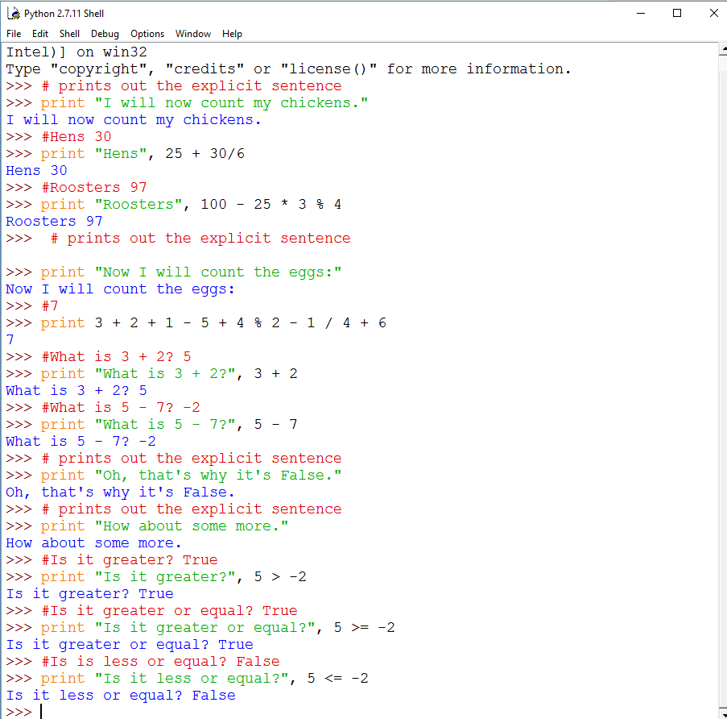

Study Drill 3

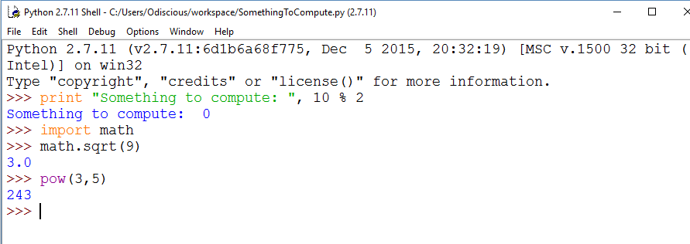

Study Drill 4

This is simply noticing that the math seems, “wrong”. There are no floating point values.

Study Drill 5

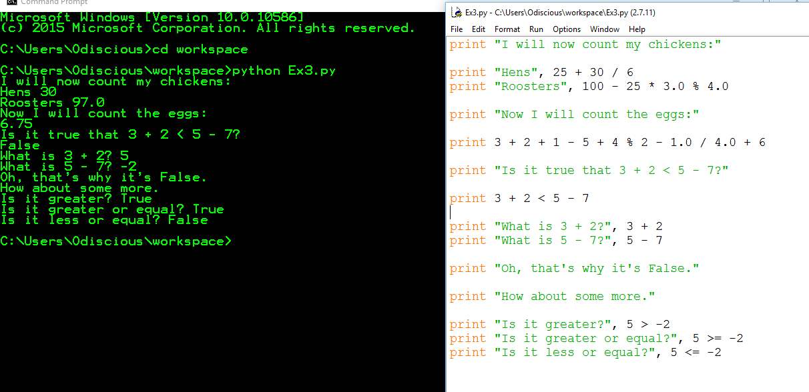

Figure 1: I ran this file from the command line to illustrate that I have Python in my PATH

Exercise 4: Study Drills # 1, 2, and 3 and run the code

Study Drill 1

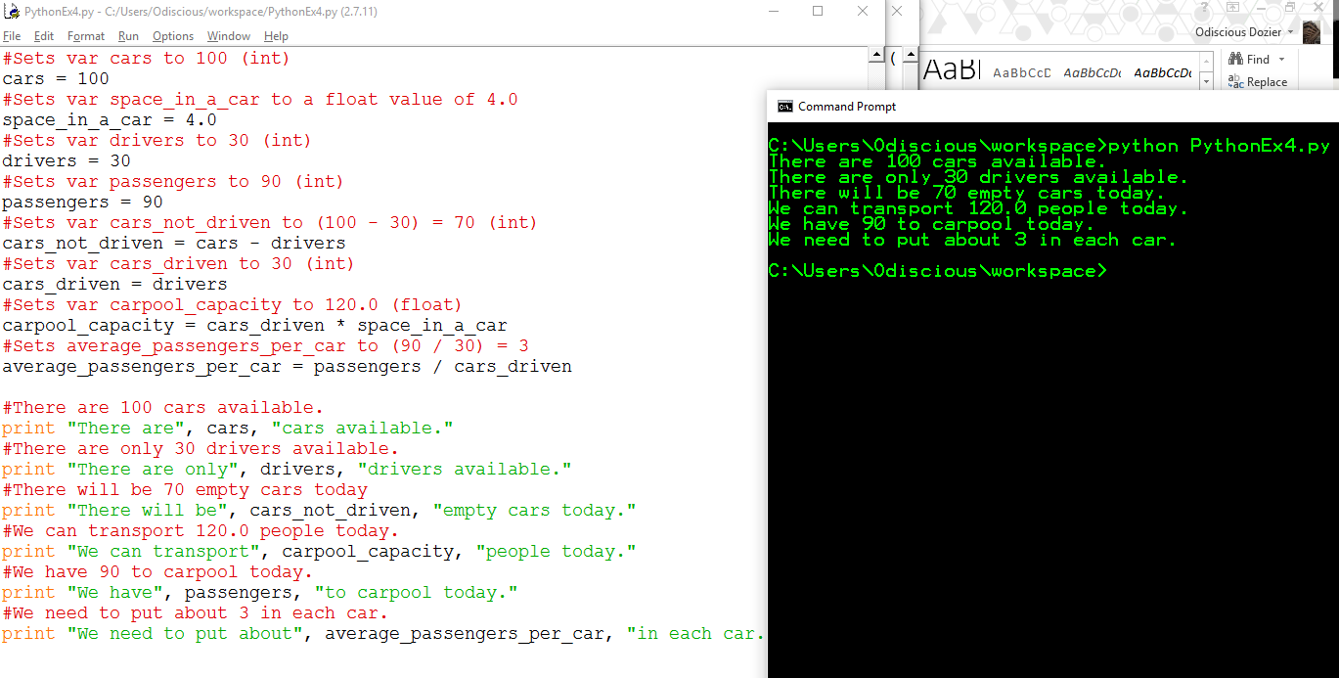

Study Drills 2 & 3

2. Read your .py file backward.

3. Read your .py file out loud, saying even the characters.

Exercise 5: Study Drills # 1, 2, and 3 and run the code

Study Drill 1

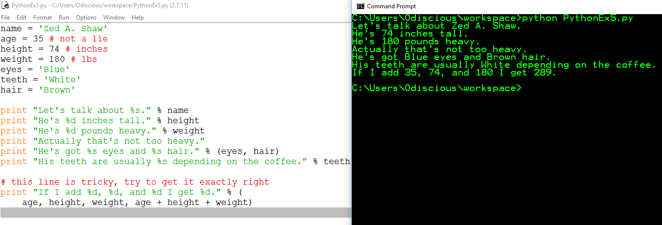

Study Drill 2

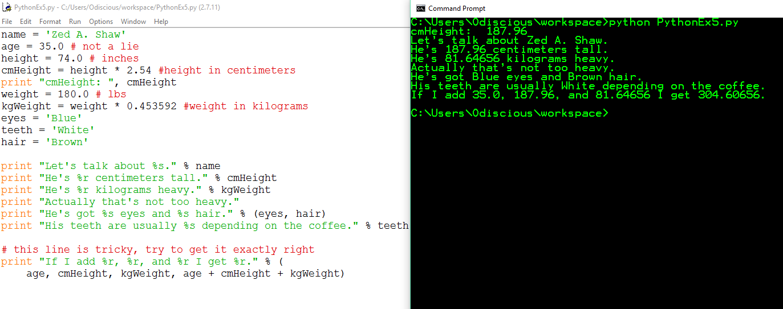

Figure 2 use of %r and %s (r unambiguous, s string format)

Study Drill 3

Python format characters - https://docs.python.org/2/library/stdtypes.html#string-formatting

